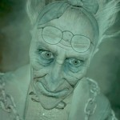
Exploring the Spirits in A Christmas Carol
- Marley (Stave 1)
Marley symbolises worldly greed and spiritual poverty.

The description of Marley
The same face: the very same. Marley in his pigtail, usual waistcoat, tights and boots; the tassels on the latter bristling, like his pigtail, and his coat-skirts, and the hair upon his head. The chain he drew was clasped about his middle. It was long, and wound about him like a tail; and it was made (for Scrooge observed it closely) of cash-boxes, keys, padlocks, ledgers, deeds, and heavy purses wrought in steel. His body was transparent, so that Scrooge, observing him, and looking through his waistcoat, could see the two buttons on his coat behind.
Key quotations
Quotation | Explanation
“I wear the chains I forged in life” | Marley’s greed is represented by the chains he wears. His worldly greed costs him spiritually.
“my spirit never roved beyond the narrow limits of our money-changing hole” | Marley never knew life beyond the counting house and this traps him in the afterlife. Marley wants Scrooge to consider his spiritual life.
“part of my penance” | A penance is paying the price for a sin. Marley’s sins were based around greed so now he must wear chairs and suffer.

Relationship with Scrooge
How does the spirit act towards Scrooge?
Marley reminds him of their friendship and how alike they were.

What changes do we see in Scrooge?
Scrooge starts to believe in spirits and suspect that his actions have consequences.

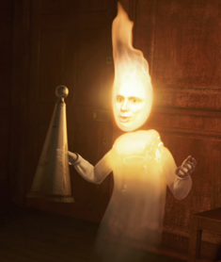
- The Ghost of Christmas Past (Stave 2)
The Ghost of Christmas Past symbolises memory.
The description of the Ghost of Christmas Past
It was a strange figure -- like a child: yet not so like a child as like an old man, viewed through some supernatural medium, which gave him the appearance of having receded from the view, and being diminished to a child's proportions. […] It wore a tunic of the purest white, and round its waist was bound a lustrous belt, the sheen of which was beautiful. It held a branch of fresh green holly in its hand; and, in singular contradiction of that wintry emblem, had its dress trimmed with summer flowers. But the strangest thing about it was, that from the crown of its head there sprung a bright clear jet of light, by which all this was visible.
Key quotations
Quotation | Explanation
“Your reclamation then. Take heed”

“A solitary child, neglected by his friends, is left here still”

“A small matter to make these silly folks so full of gratitude”

Relationship with Scrooge
How does the spirit act towards Scrooge?

What changes do we see in Scrooge?

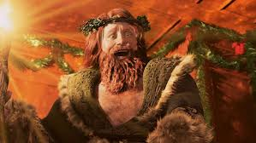
- The Ghost of Christmas Present (Stave 3)
The Ghost of Christmas Present symbolises generosity and goodwill.
The description of the Ghost of Christmas Present
It was clothed in one simple green robe, or mantle, bordered with white fur. This garment hung so loosely on the figure, that its capacious breast was bare, as if disdaining to be warded or concealed by any artifice. Its feet, observable beneath the ample folds of the garment, were also bare; and on its head it wore no other covering than a holly wreath, set here and there with shining icicles. Its dark brown curls were long and free; free as its genial face, its sparkling eye, its open hand, its cheery voice, its unconstrained demeanour, and its joyful air. Girded round its middle was an antique scabbard; but no sword was in it, and the ancient sheath was eaten up with rust.
Key quotations
Quotation | Explanation
“To any kindly given”

“This boy is Ignorance. This girl is Want”

“Are there no prisons? Are there no workhouses?”

Relationship with Scrooge
How does the spirit act towards Scrooge?

What changes do we see in Scrooge?

- The Ghost of Christmas Yet to Come (Stave 4)
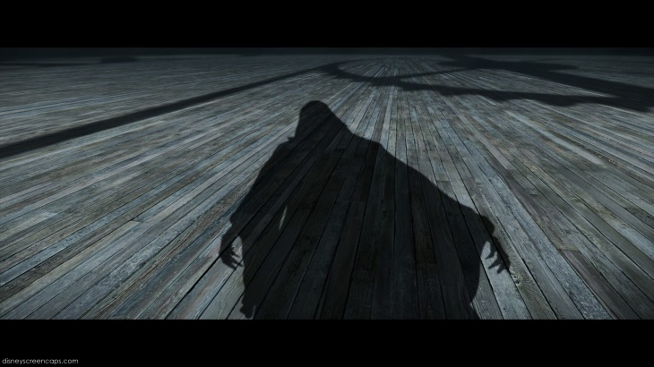
The Ghost of Christmas Yet to Come symbolises death.
The description of the Ghost of Christmas Present
The Phantom slowly, gravely, silently approached. When it came, Scrooge bent down upon his knee; for in the very air through which this Spirit moved it seemed to scatter gloom and mystery. It was shrouded in a deep black garment, which concealed its head, its face, its form, and left nothing of it visible save one outstretched hand. But for this it would have been difficult to detach its figure from the night, and separate it from the darkness by which it was surrounded. He felt that it was tall and stately when it came beside him, and that its mysterious presence filled him with a solemn dread. He knew no more, for the Spirit neither spoke nor moved.
Key quotations
Quotation (spoken by Scrooge) | Explanation
“The night is waning fast, and it is precious time to me”

“The case of this unhappy man might be my own”

“I am not the man I was”

Relationship with Scrooge
How does the spirit act towards Scrooge?

What changes do we see in Scrooge?

